Guide to Art Criticism
Here is a list of guiding question to ask (students and parents!) when discussing or viewing all types of art. There are many different versions of art: Visual, performance, culinary, musical

Step 1: Describe
What kinds of things do you see in this artwork?
What words would you use to describe this artwork?
How would you describe the lines in this picture? The shapes? The colors? What does this artwork show?
Look at this artwork for a moment. What observations can you make about it?
How would you describe this artwork to a person who could not see it?
How would you describe the people in this picture? Are they like you or different?
How would you describe (the place depicted in) this artwork?

Step 2: Relate
What does this artwork remind you of?
What things do you recognize in this artwork? What things seem new to you?
How is this artwork like other artworks you’ve seen? What are some important differences?
What do these two artworks have in common?
How is this picture different from real life?
What interests you most about this work of art?

Step 3: Analyze
Which objects seems closer to you? Further away?
What can you tell me about the colors in this artwork?
What color is used the most in this artwork?
What makes this artwork look crowded?
What can you tell me about the person in this artwork?
What can you tell me about how this person lived? How did you arrive at that idea?
What do you think is the most important part of this picture?
How do you think the artist made this work?
What questions would you ask the artist about this work, if s/he were here?

Step 4: Interpret
What title would you give to this artwork? What made you decide on that title?
What other titles could we give it?
What do you think is happening in this artwork? What else could be happening?
What sounds would this artwork make (if it could)?
What do you think is going on in this picture? How did you arrive at that idea?
What do you think this artwork is about? How did you come up that idea?
Pretend you are inside this artwork. What does it feel like?
What do you think this (object) was used for? How did you arrive at that idea?
Why do you suppose the artist made this artwork? What makes you think that?
What do you think it would be like to live in this artwork? What makes you think that?

Step 5: Judgment
What do you think is good about this artwork? What is not so good?
Do you think the person who painted this do a good or bad job? What makes you think so?
Why do you think other people should see this work of art?
What do you think other people would say about this work? Why do you think that?
What grade would you give the artist for this work? How did you arrive at that grade?
What would you do with this work if you owned it?
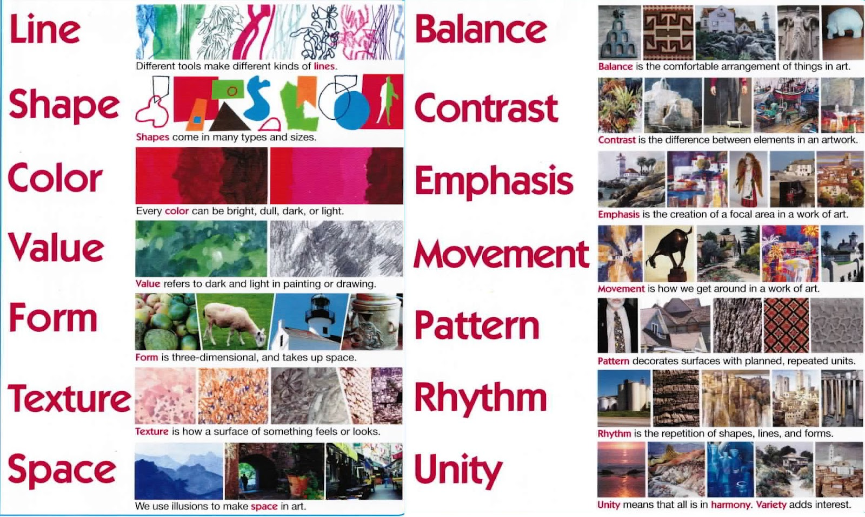
What do you think is worth remembering about this artwork?

